Menu:

<%@ Page Language="C#" AutoEventWireup="true" CodeFile="Default7.aspx.cs" Inherits="Default7" %>

<!DOCTYPE html>

<html xmlns="http://www.w3.org/1999/xhtml">

<head runat="server">

<title></title>

</head>

<body>

<form id="form1" runat="server">

<div>

<asp:Menu ID="Menu1" runat="server" BackColor="#FFFBD6" DynamicHorizontalOffset="2" Font-Names="Verdana" Font-Size="0.8em" ForeColor="#990000" StaticSubMenuIndent="10px" StaticDisplayLevels="2">

<DynamicHoverStyle BackColor="#990000" ForeColor="White" />

<DynamicMenuItemStyle HorizontalPadding="5px" VerticalPadding="2px" />

<DynamicMenuStyle BackColor="#FFFBD6" />

<DynamicSelectedStyle BackColor="#FFCC66" />

<Items>

<asp:MenuItem Text="ASP.net" Value="ASP.net">

<asp:MenuItem NavigateUrl="~/Default.aspx" Text="Default page" Value="Default page"></asp:MenuItem>

</asp:MenuItem>

<asp:MenuItem Text="Convert" Value="Convert">

<asp:MenuItem NavigateUrl="~/Default2.aspx" Text="Word or Excel" Value="Word or Excel"></asp:MenuItem>

</asp:MenuItem>

<asp:MenuItem Text="File upload" Value="File upload">

<asp:MenuItem NavigateUrl="~/Default4.aspx" Text="upload" Value="upload"></asp:MenuItem>

</asp:MenuItem>

<asp:MenuItem Text="Download" Value="Download">

<asp:MenuItem NavigateUrl="~/Default5.aspx" Text="Download" Value="Download"></asp:MenuItem>

</asp:MenuItem>

<asp:MenuItem Text="Recaptca" Value="Recaptca">

<asp:MenuItem NavigateUrl="~/Default6.aspx" Text="Try it" Value="Try it"></asp:MenuItem>

</asp:MenuItem>

</Items>

<StaticHoverStyle BackColor="#990000" ForeColor="White" />

<StaticMenuItemStyle HorizontalPadding="5px" VerticalPadding="2px" />

<StaticSelectedStyle BackColor="#FFCC66" />

</asp:Menu>

<br />

statically declared menu</div>

</form>

</body>

</html>

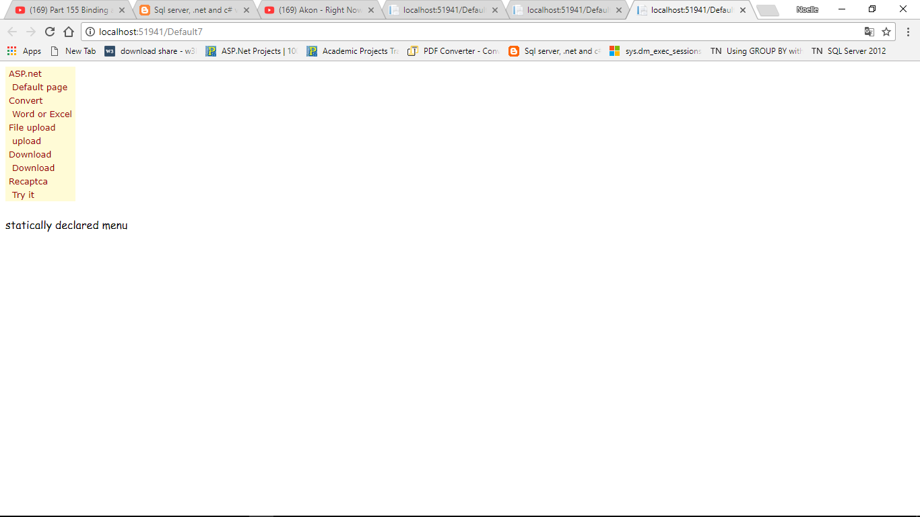

***View with XML but without Xpath***

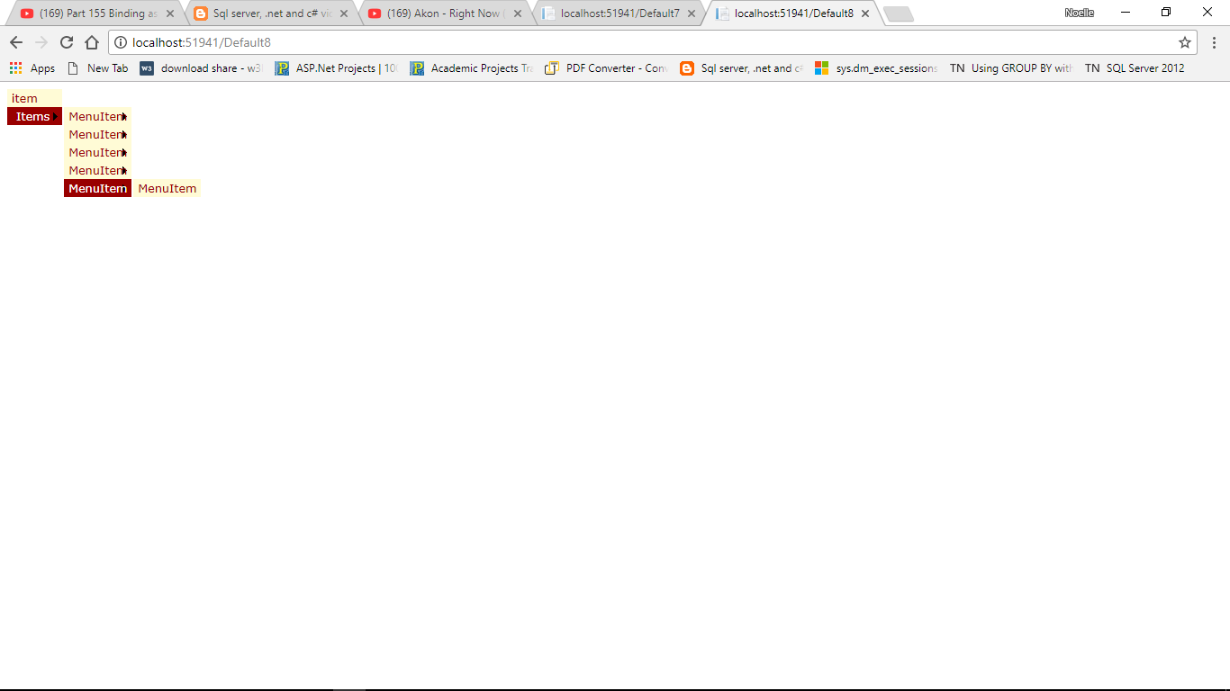

Asp page:

<%@ Page Language="C#" AutoEventWireup="true" CodeFile="Default8.aspx.cs" Inherits="Default8" %>

<!DOCTYPE html>

<html xmlns="http://www.w3.org/1999/xhtml">

<head runat="server">

<title></title>

</head>

<body>

<form id="form1" runat="server">

<div>

***<asp:XmlDataSource ID="XmlDataSource1" DataFile="~/XMLFile.xml" runat="server"></asp:XmlDataSource> //Datasource***

<asp:Menu ID="Menu1" ***DataSourceID="XmlDataSource1"*** runat="server" BackColor="#FFFBD6" DynamicHorizontalOffset="2" Font-Names="Verdana" Font-Size="0.8em" ForeColor="#990000" StaticSubMenuIndent="10px" StaticDisplayLevels="2">

<DynamicHoverStyle BackColor="#990000" ForeColor="White" />

<DynamicMenuItemStyle HorizontalPadding="5px" VerticalPadding="2px" />

<DynamicMenuStyle BackColor="#FFFBD6" />

<DynamicSelectedStyle BackColor="#FFCC66" />

<StaticHoverStyle BackColor="#990000" ForeColor="White" />

<StaticMenuItemStyle HorizontalPadding="5px" VerticalPadding="2px" />

<StaticSelectedStyle BackColor="#FFCC66" />

</asp:Menu>

</div>

</form>

</body>

</html>

Xml file:

<?xml version="1.0" encoding="utf-8" ?>

<item>

<Items>

<MenuItem ***NavigateUrl="~/Default9.aspx"*** Text="ASP.net" > //arbitrary Default9 page

<MenuItem NavigateUrl="~/Default.aspx" Text="Default page" />

</MenuItem>

<MenuItem ***NavigateUrl="~/Default9.aspx"*** Text="Convert" >

<MenuItem NavigateUrl="~/Default2.aspx" Text="Word or Excel" />

</MenuItem>

<MenuItem ***NavigateUrl="~/Default9.aspx"*** Text="File upload" >

<MenuItem NavigateUrl="~/Default4.aspx" Text="upload" />

</MenuItem>

<MenuItem ***NavigateUrl="~/Default9.aspx"*** Text="Download" >

<MenuItem NavigateUrl="~/Default5.aspx" Text="Download" />

</MenuItem>

<MenuItem ***NavigateUrl="~/Default9.aspx"*** Text="Recaptca" >

<MenuItem NavigateUrl="~/Default6.aspx" Text="Try it"/>

</MenuItem>

</Items>

</item>

***Mistake (*without having xpath menu starts with Items)**

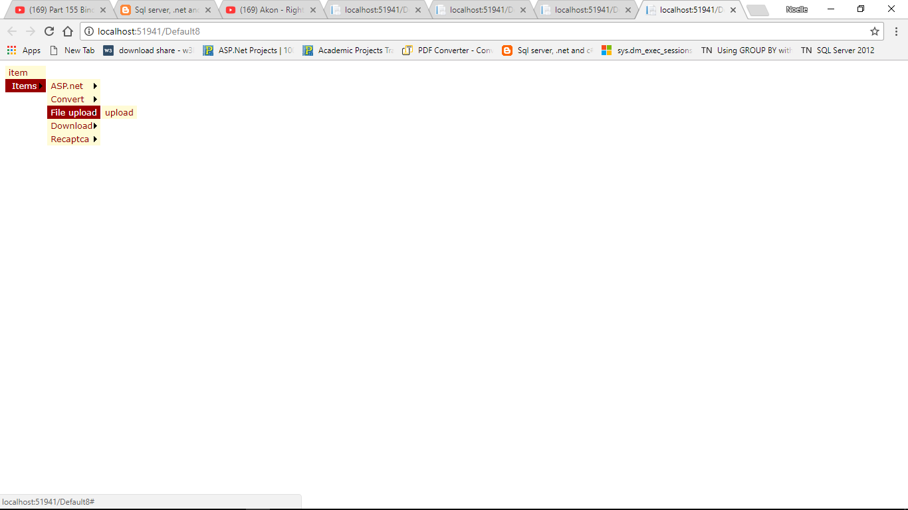

<%@ Page Language="C#" AutoEventWireup="true" CodeFile="Default8.aspx.cs" Inherits="Default8" %>

<!DOCTYPE html>

<html xmlns="http://www.w3.org/1999/xhtml">

<head runat="server">

<title></title>

</head>

<body>

<form id="form1" runat="server">

<div>

<asp:XmlDataSource ID="XmlDataSource1" DataFile="~/XMLFile.xml" runat="server"></asp:XmlDataSource>

<asp:Menu ID="Menu1" DataSourceID="XmlDataSource1" runat="server" BackColor="#FFFBD6" DynamicHorizontalOffset="2" Font-Names="Verdana" Font-Size="0.8em" ForeColor="#990000" StaticSubMenuIndent="10px" StaticDisplayLevels="2">

<DynamicHoverStyle BackColor="#990000" ForeColor="White" />

<DynamicMenuItemStyle HorizontalPadding="5px" VerticalPadding="2px" />

<DynamicMenuStyle BackColor="#FFFBD6" />

<DynamicSelectedStyle BackColor="#FFCC66" />

***<DataBindings>***

***<asp:MenuItemBinding DataMember="MenuItem" TextField="Text" />***

***//DataMember property comes from XML File.***

***</DataBindings>***

<StaticHoverStyle BackColor="#990000" ForeColor="White" />

<StaticMenuItemStyle HorizontalPadding="5px" VerticalPadding="2px" />

<StaticSelectedStyle BackColor="#FFCC66" />

</asp:Menu>

</div>

</form>

</body>

</html>

***Correction***

At .aspx page

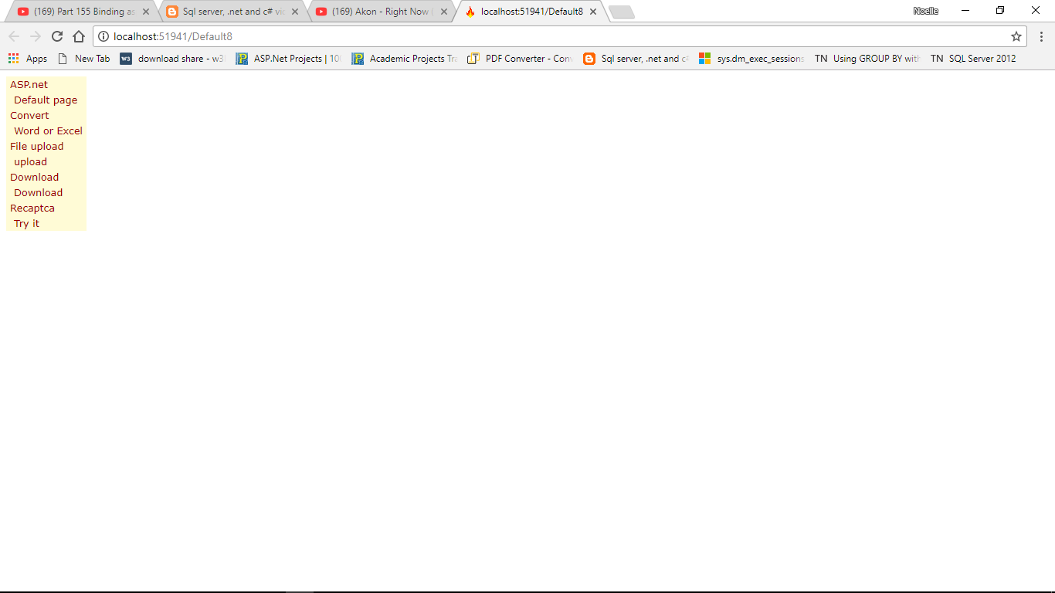

<%@ Page Language="C#" AutoEventWireup="true" CodeFile="Default8.aspx.cs" Inherits="Default8" %>

<!DOCTYPE html>

<html xmlns="http://www.w3.org/1999/xhtml">

<head runat="server">

<title></title>

</head>

<body>

<form id="form1" runat="server">

<div>

<asp:XmlDataSource ID="XmlDataSource1" ***XPath="/item/Items/MenuItem"*** DataFile="~/XMLFile.xml" runat="server"></asp:XmlDataSource>

<asp:Menu ID="Menu1" DataSourceID="XmlDataSource1" runat="server" BackColor="#FFFBD6" DynamicHorizontalOffset="2" Font-Names="Verdana" Font-Size="0.8em" ForeColor="#990000" StaticSubMenuIndent="10px" StaticDisplayLevels="2">

<DynamicHoverStyle BackColor="#990000" ForeColor="White" />

<DynamicMenuItemStyle HorizontalPadding="5px" VerticalPadding="2px" />

<DynamicMenuStyle BackColor="#FFFBD6" />

<DynamicSelectedStyle BackColor="#FFCC66" />

<DataBindings>

<asp:MenuItemBinding DataMember="MenuItem" TextField="Text" NavigateUrlField="NavigateUrl" />

</DataBindings>

<StaticHoverStyle BackColor="#990000" ForeColor="White" />

<StaticMenuItemStyle HorizontalPadding="5px" VerticalPadding="2px" />

<StaticSelectedStyle BackColor="#FFCC66" />

</asp:Menu>

</div>

</form>

</body>

</html>